**LAB 10**

**Participation Activities**

**4.5.2**

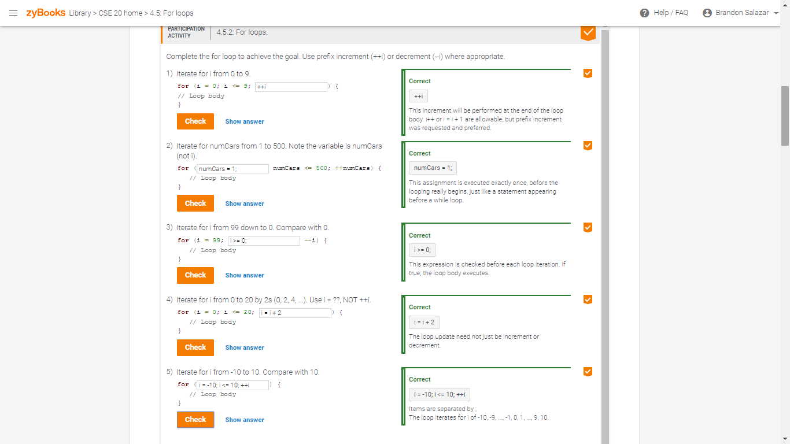

**4.5.3**

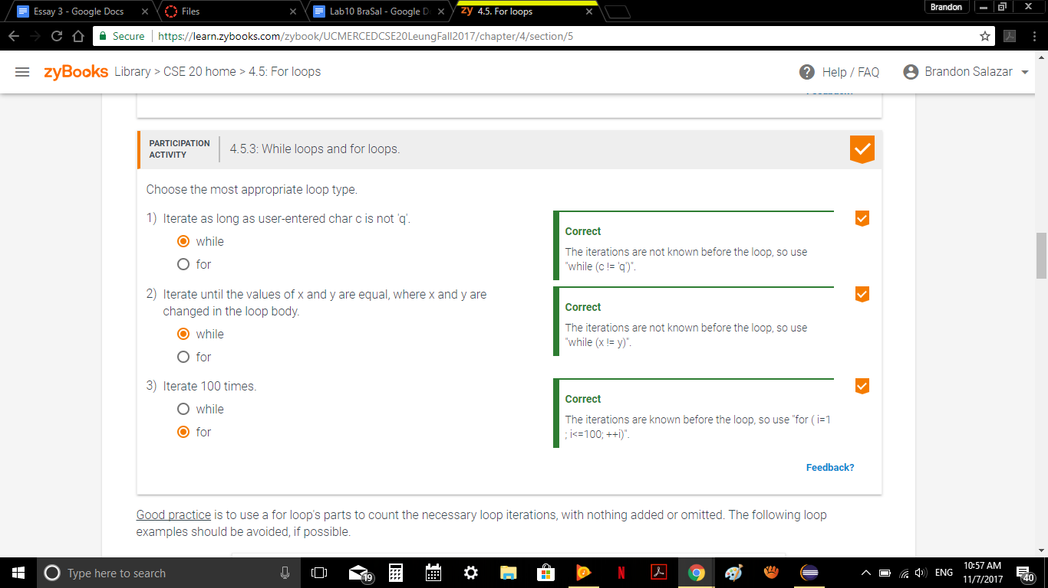

**4.5.4**

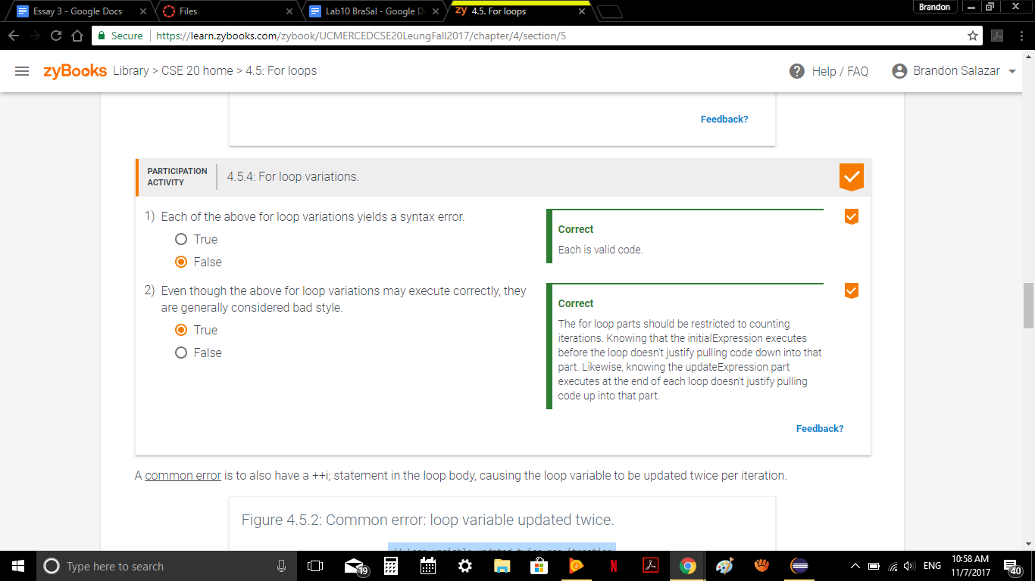

**4.6.2  
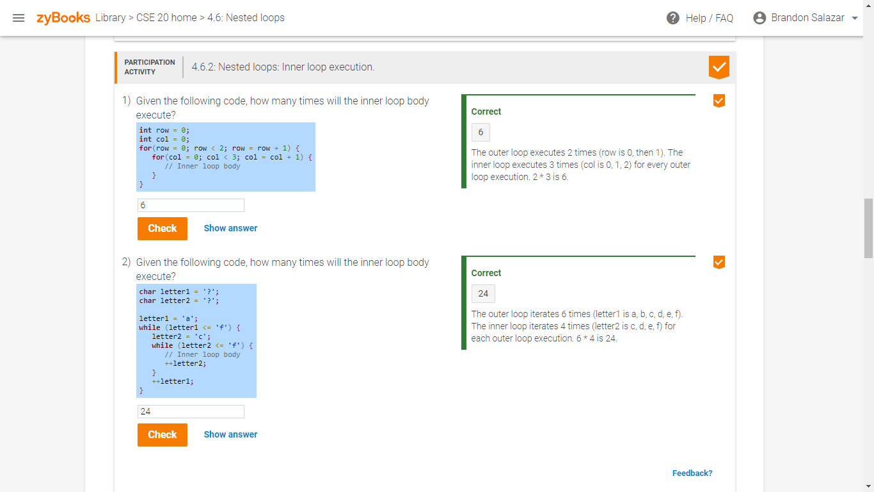**

**(Assessment) Logic Check**

**1)How many iterations for each loop where max = 10 and incr = 3**

**a)for (int i = 0; i < max; i++)**

Iterations = 10

**b)for (int i = 0; i < max; i += 2)**

Iterations = 5

**c) for (int i = 0; i < max; i += incr)**

Iterations = 4

**d)for (int i = incr; i < max; i += incr)**

Iterations = 3

**e)for (int i = max; i > 0; i--)**

Iterations = 10

**f)for (int i = max; i < 0; i--)**

Iterations = none

**g)for (int i = 1; i < max; i *= incr)**

Iterations = 3

**h)for (int i = 0; i < max; i *= incr)**

Iterations = infinitely

**2)How will while(true) behave if the loops continue as long as the condition is true?**

It will continue to execute the statement until the **while(true)** becomes a **while(false)**, at that point, the loop will stop and it will continue with the rest of the program outside the loop.

**3)When should you use**

**a)For-loop?**

In general, you should use a for loop when you know how many times the loop should run.

**b)Do-while loop?**

In contrast with the while loop, which tests the condition before the code within the block is executed, the do-while loop is an exit-condition loop. This means that the code must always be executed first and then the expression or test condition is evaluated. If it is true, the code executes the body of the loop again.